Enveloper for Software and Data Protection

Using Pen Drive Protection

User Guide
[For Basic Edition]

Contents
Page No
1. | General | 3
2. | How to Download | 4
3. | Pre-Requisites | 5
4. | Application User interface | 6
5. | Target System | 7
6. | Input Files | 8
7. | Security Information | 10
8. | Output File | 11
9. | Error Messages while creating envelope | 12
10. | Error Messages while running enveloped exe | 13

- General
Software Envelope allows binding multiple files in to a single executable. The new enveloped executable is a binary file and it is very difficult to reverse engineer the file.
Normally when you use a software protection tool, you use a DLL to verify authorisation key from a hardware [it can be a dongle, USB flash drive, or any other device].
The hacker or cracker normally create an identical DLL to by-pass the functions or produces a duplicate hardware.
When you envelope the DLL and all other files in to a single executable, by-pass technique do not work as you have a single executable.
Envelopes can be used for one or more of following:
- Bind main program and DLL’s together
- Bind main program and its data file [for example a PDF with PDF Reader]
- Run legacy software on advanced OS [for example a VB6 application on Vista and Win 7] by creating a single file which will not need installation
- Prevent reverse engineering of software
- Protect software with dongles / USB key or any other security tool.
Normally it is very easy to reverse engineer a .net program or any other program as dissemblers are easily available, normally free from web. Envelope will safeguard your programs from dissemblers.

- How to Download
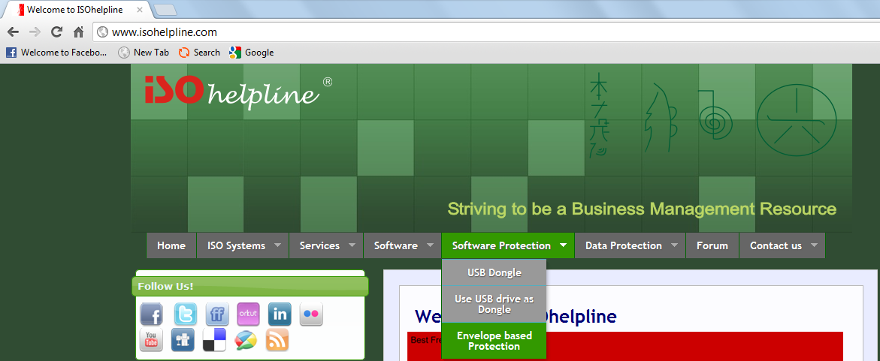
Go to www.isohelpline.com, click “Software Protection” >> “Envelope based Protection”
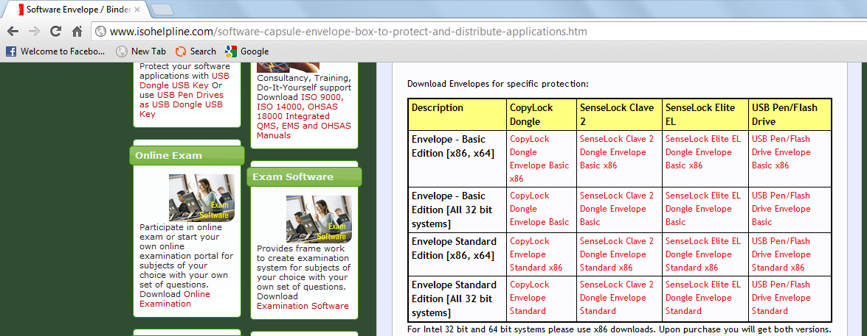
Download the envelope suitable for your system.
- X86, x64
Select this option if YOUR Machine has Intel based CPU or compatible.
- All 32 bit systems
Select this option if YOUR Machine has non-Intel compatible CPU (for example: AMD Processor)
Versions
Basic: Allows creating single protected EXE from an executable and [optional] a data file.
Standard: Allows creating single protected EXE from an executable, [optional] a data file and any number of other files like plug-in, DLL, COM, OCX etc.
- Pre-Requisites
The enveloper requires Microsoft Dot Net Framework 2.0 or 4.0
The final EXE which is distributed to end user also requires Microsoft Dot Net Framework 2.0 or 4.0

- Application user Interface

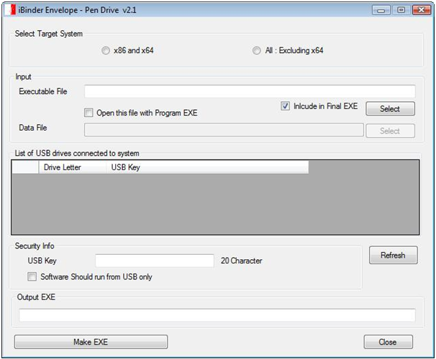

Make sure that your File path, File name and USB key should not have any Blank space.

- Target System
Technology has given us many good things but also created complexity for programmers. A program designed for 64 bit hardware do not work on a 32 bit hardware or even a Intel hardware program do not work [or do not work efficiently] on other hardware architecture like AMD.
Our envelope will allow you to select the target system for your final executable which you will be distributing. If your existing files are designed for x86, select the same here. Please note that this will not change the target system of your existing exe but will simply create a new executable for the selected system.

Select the System on which the client is working on.
- X86 and x64
Select this option if client Machine has Intel based CPU or compatible.
- All : Excluding x64
Select this option if client Machine has non-Intel compatible CPU (for example: AMD Processor)

- Input Files
The first file must be an executable file. The envelope will run this file only. Other files will depend on this first executable and can used from inside this application or as a link.
Guidance for Including “Executable File” in “Final EXE”:
- If the executable file is part of windows system, do not include it in the final EXE like “notepad.exe”
- If you are binding a data file and your main executable is not owned by you or you do not have distribution rights, do not include executable in final EXE.
Data File
Data file, if added will be opened as a command line operation. Your main program [executable] should support command line operation to open the file. For example:
C:\notepad.exe readme.txt
The above command will run notepad and open readme.txt file.

1. Uncheck this checkbox if you don’t want to bind the Executable EXE in Output EXE Otherwise keep it checked.

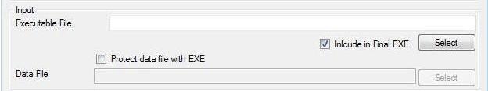
2. We can Choose Executable File with User Interface by Pressing on the Select button.
3. You can also type the name of the Executable File name [if “Include in Final EXE” is unchecked”] Like: Notepad.exe
Remember that file name is case sensitive for enveloper.

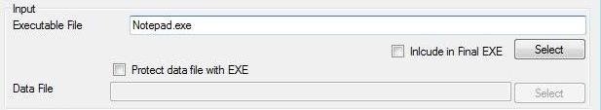
Select the data files you want to protect with this EXE by first clicking on the check box as pointed.

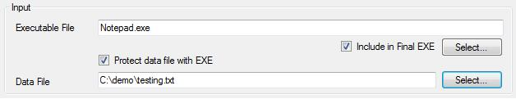
After pressing on the select button open a new dialog, and then select the data file.
- Security Information
This information depends upon the security hardware. This will ensure verification as per data specified by you.
Press on Refresh Button if you do not visible the drive no. after plugin the pendrive.

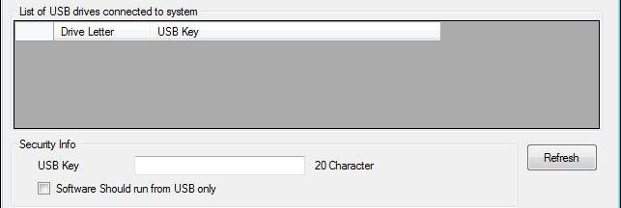
Or
Simply type the exact drive no. of the drive for which you want to make the enveloped exe.

Select the Drive no. of the drive which will be displayed that act as a USB key.
Check on the check box if you want to run the exe from USB only.

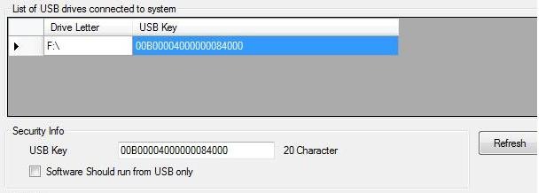
This feature is useful for providing security.

Image showing filled data

- Output File

This is your final single EXE including all the files you have selected to add.
Specify the proper file location.
This file should be given to end user.
Give the location of the Output EXE where you want to create it. Make sure that the path you have given is correct.

Then press on the Make EXE Button in order to create the desired EXE.

- Run the generated Enveloped EXE by just double clicking it, this EXE will work only with the particular Clave2 dongle having unique identity for providing security.

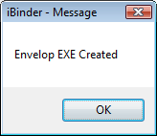

- Error Messages while creating envelope

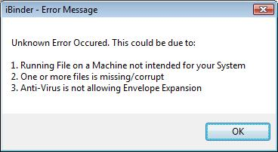

During envelope creation, you may encounter above error message. The resolution could be as follows:
- Use _x86 enveloper on Intel CPU based machines including 64 bit systems and _all enveloper on other CPU.
- Make sure that files you have added are available and they are not corrupt
- Disable anti-virus and try again
- Copy the Program EXE in the enveloper folder [or vice versa] and try.
- Before adding file, copy them in enveloper folder [keeping desired directory structure].

- Error Messages while running enveloped EXE

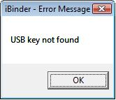

If the user has not attached the vender supplied pen drive/flash drive while executing the EXE, this error messages may appear indicating failure of verification.

Please contact us for purchasing SenseLock Dongle:

Innovative Matrix Softech Pvt. Ltd.
Door No. 7005, 7th Floor, Emerald House
1-7-264 Kalasiguda
Near Paradise Circle
Sarojini Devi Road
Secunderabad - 500 003
India.

Phone: 040 32518777
Mobile: 91.93485 18777

Email: mail@isohelpline.com

Website: www.isohelpline.com

